**I. Pen-and-paper**

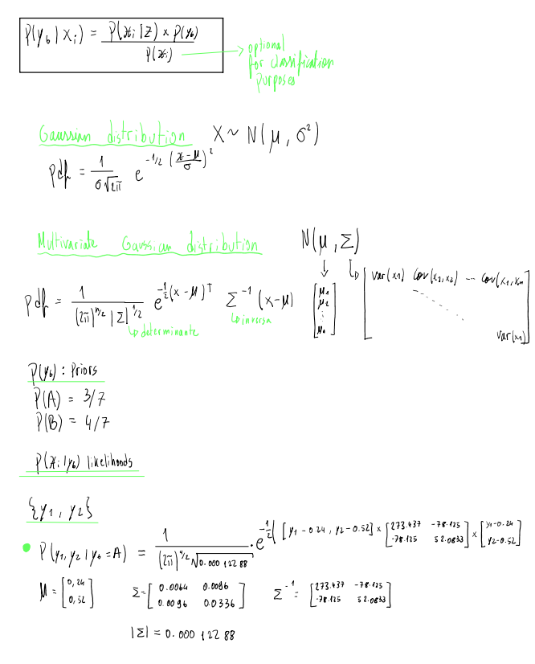

1)

a-

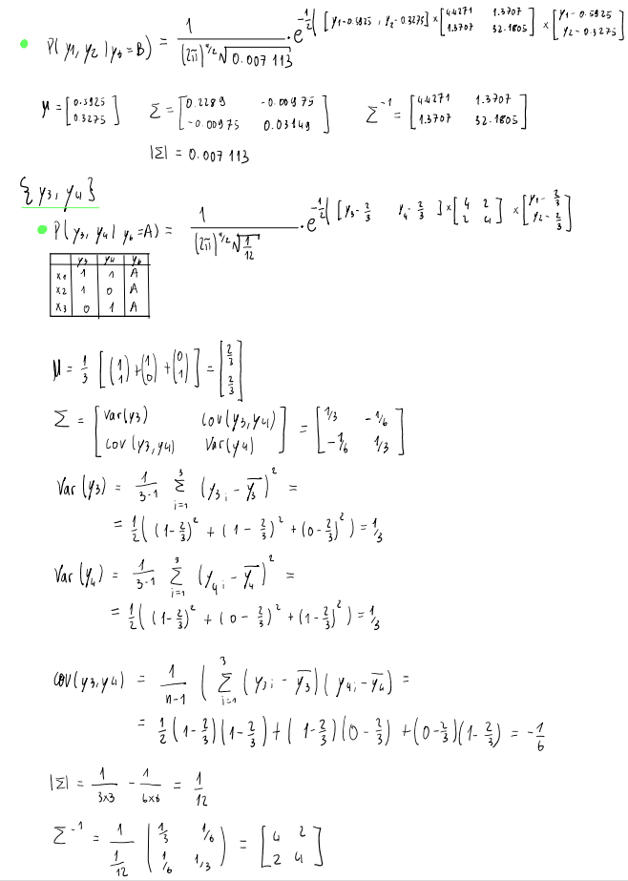

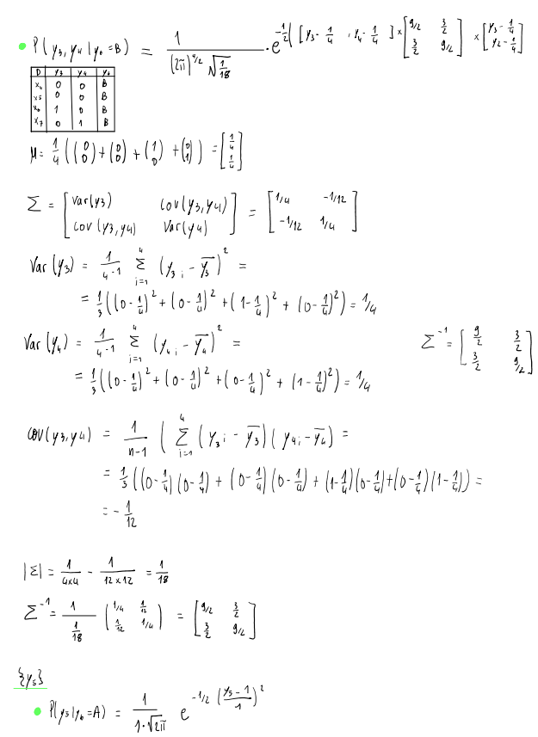

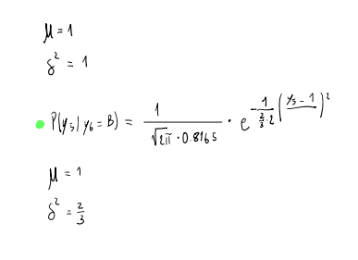

Python code:

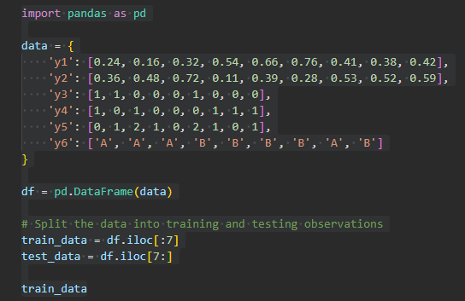

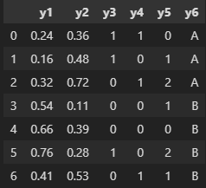

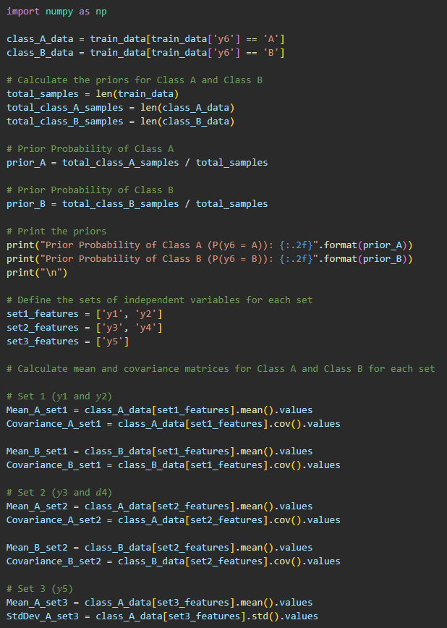

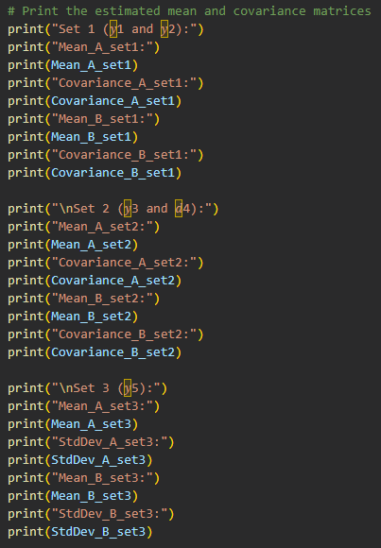

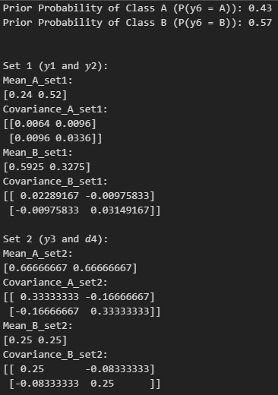

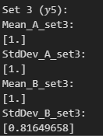

b-

c-

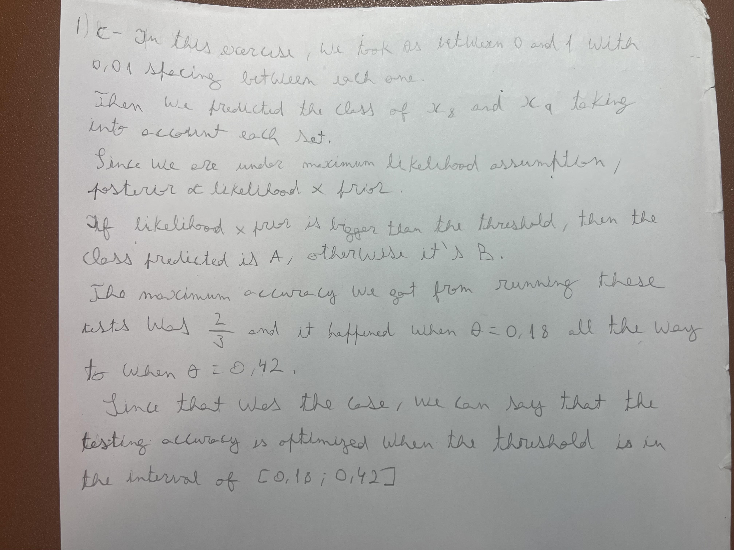

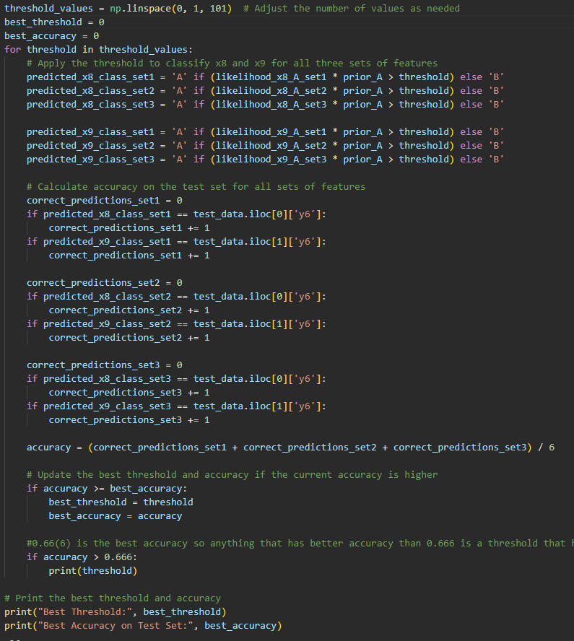

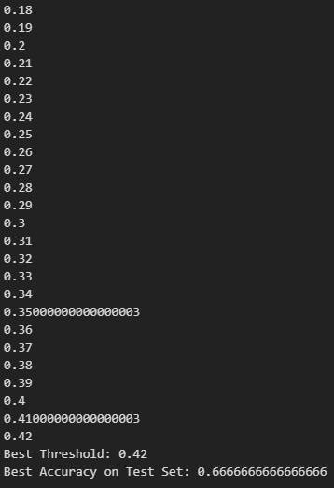

2)

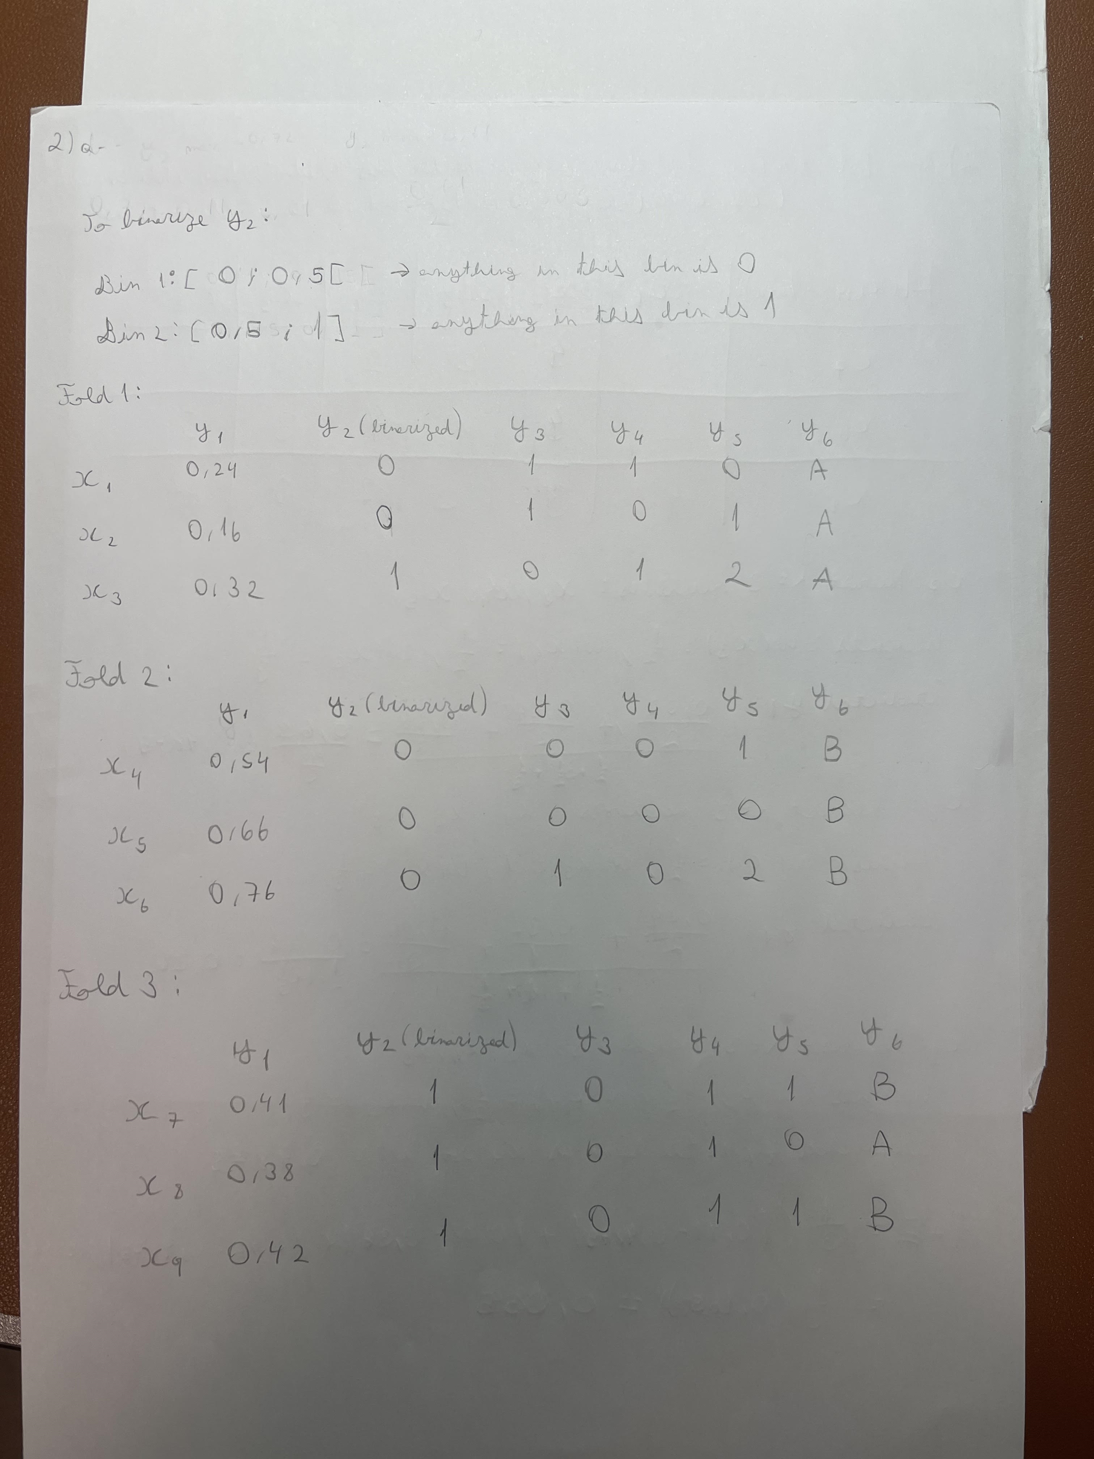a-

b-

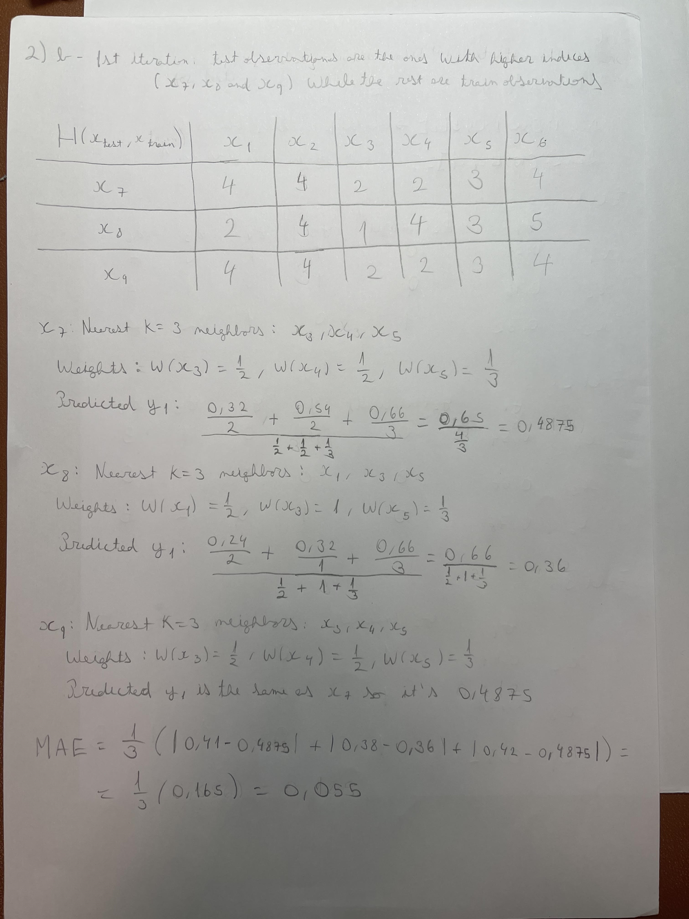

**II. Programming and critical analysis**

1)

a-

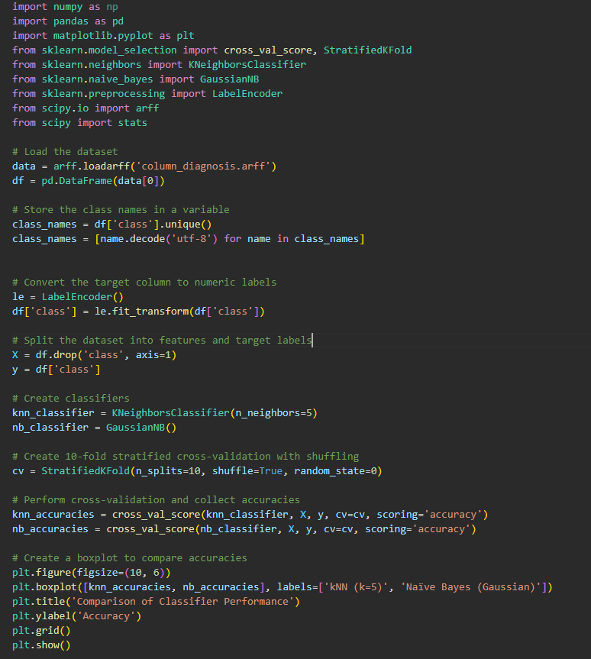

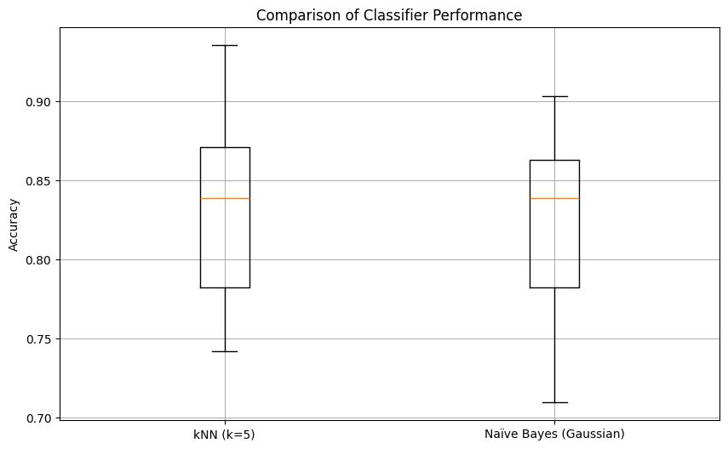

b-

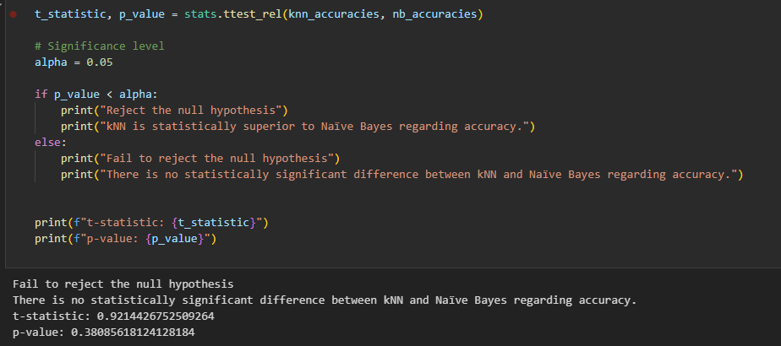

**2)**

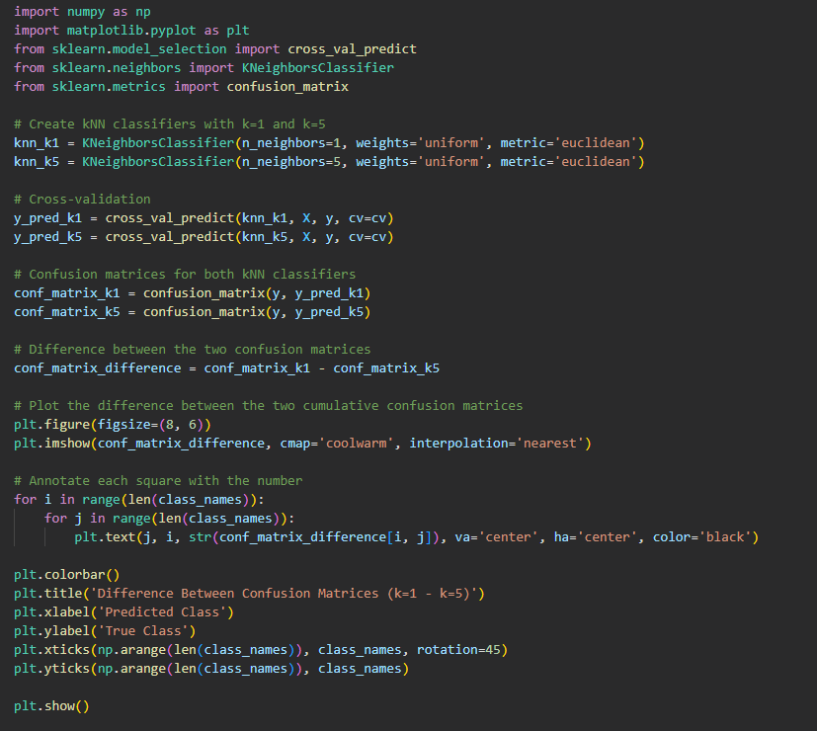

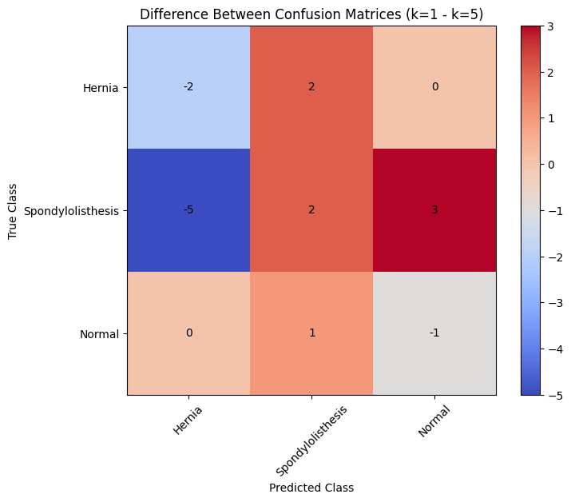

**The diagonal elements of the matrix represent the true positives.**

  - Positive values indicate cases where k=1 performed better than k=5, with more correct classifications.

Off-diagonal elements represent the differences in misclassifications between the two classifiers.

   - Negative values indicate cases where k=1 performed better than  k=5, having fewer misclassifications.

For Spondylolisthesis, the kNN classifier with k=1 outperforms the one with k=5 as it has more correct predictions and fewer misclassifications.

For Hernia Normal class, the kNN classifier with k=5 has a slight edge in terms of correct predictions.

If correctly classifying Spondylolisthesis is more critical, then k=1 is preferable. However, if balanced performance across all classes is preferred, k=5 may be a better choice as it reduces misclassifications for other classes.

**3)**

**1. Naïve Bayes assumes that the features are independent from one another given the class label. However, that might not be the case in column_diagnosis since most of the times, medical terms or symptoms may be related ("pelvic_incidence" "pelvic_tilt") , therefore assuming their independence won't hold in real-world medical data,leading to bad performance since the model can't capture those complex relationships between features.**

2. In column_diagnosis, Spondylolisthesis is much more common than Hernia. This means the classes are imbalanced and naïve Bayes might be biased towards the more common class and might struggle to accurately classify the minority class, which can result in a poor predictive performance.

3. Naïve Bayes works best with discrete or categorical data. However, in column_diagnosis all data is numerical, so we would need to discretize the data to use the model to it's fullest potential, but this can lead to information loss and may affect the performance of the model.

As for continuous features, Naïve Bayes assumes they follow a Normal distribution. In this dataset, the distribution of some features are not that well aproximated by the normal distribution like "degree_spondylolisthesis", and modeling them as such can lead to inaccurate predictions.

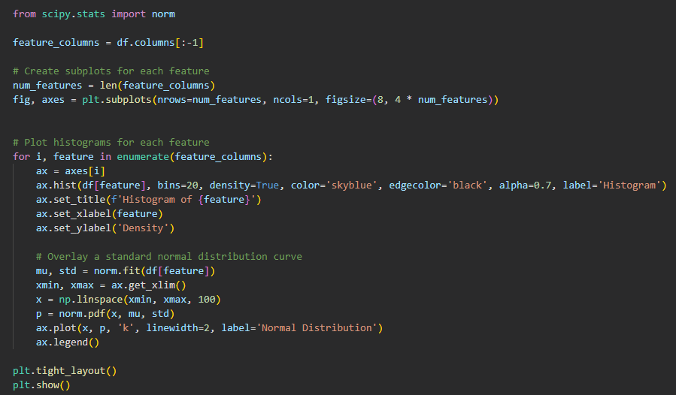

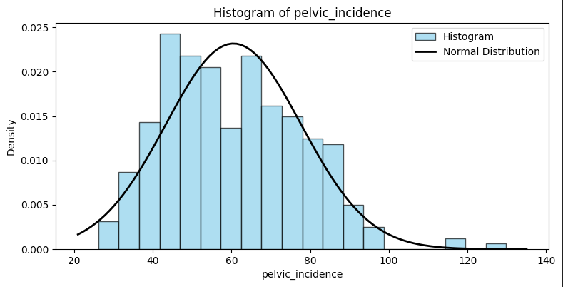

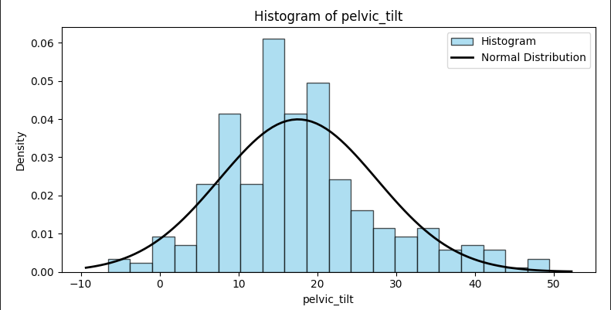

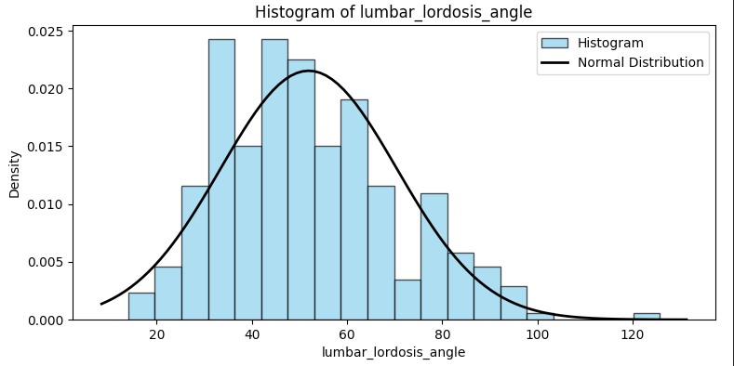

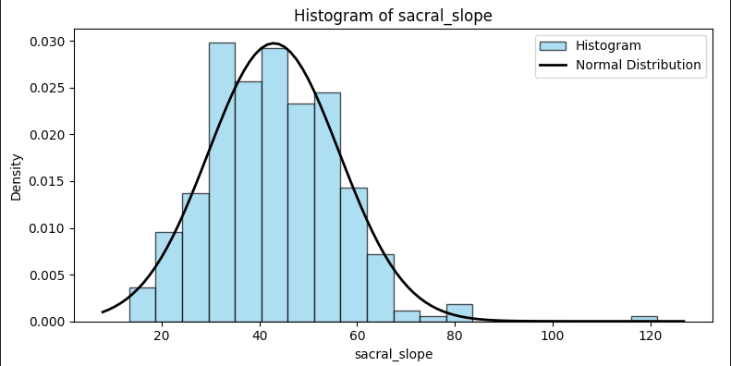

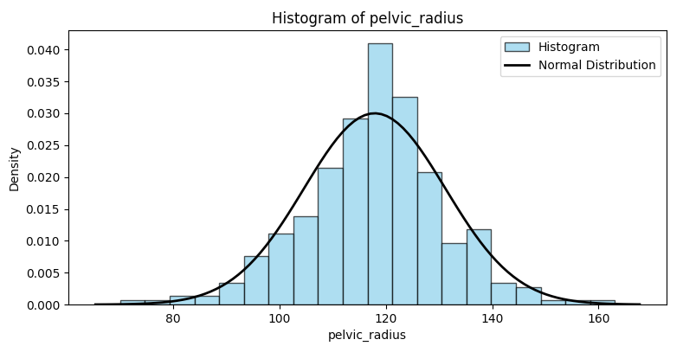

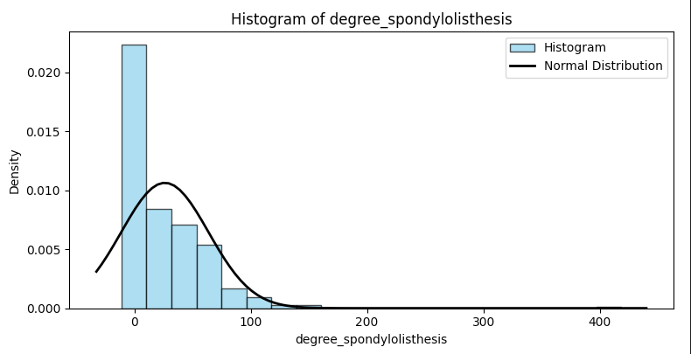

**END**